**Design Case Document**

**Module Information: Fibonacci sequence**

This exercise requires you to write a C# program to get it to display the first n Fibonacci numbers.

Note: The Fibonacci Sequence is the series of numbers: 0, 1, 1, 2, 3, 5, 8, 13, 21, 34, . . .

Each subsequent number is the sum of the previous two.

Assuming n is set to 8 the following Fibonacci sequence should be displayed -> 0,1,1,2,3,5,8,13

Include details on how to run the program when submitting your work.

Extra consideration will be given to candidates who also include a unit test for the program with appropriate instructions on how to run the test.

[**Recommended Tools**](https://www.softwaretestinghelp.com/test-case-template-examples/#Recommended_Tools)**:**

Before running the test cases Please check the below tools: 1. Visual studio (Mandatory) 2. Postman client (optional).

**Test Monitor:**

Please follow the below process to test.

* Please download the project from GitHub.
* Load the project using Visual Studio.
* I created two projects inside the solution (dxc.Fibonacci).

1. dxc.FibonacciAPI (It is an Web API, which will provide us the end point to call it from any other project or postmant)
2. dxc.FibonacciTest

* Please make sure dxc.FibonacciAPI will be your startup project. If it was not set then please right on the project and select as startup project.
* Make the visual studio run mode or you can press f5 to run the project.

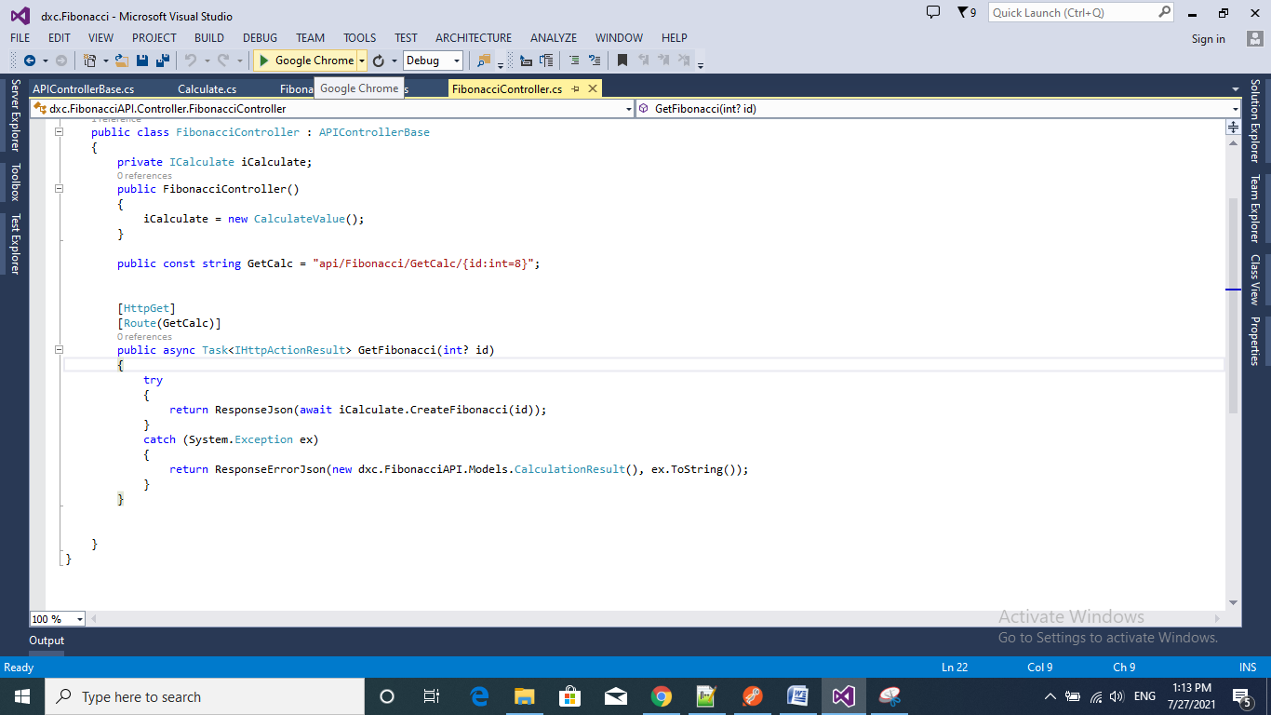

* By Default it will load the <http://localhost:1079/>
* Then Please change the URL make add end point URL. It will be like : <http://localhost:1079/api/Fibonacci/GetCalc/10>
  + <http://localhost:1079/api/Fibonacci/GetCalc/8>
  + <http://localhost:1079/api/Fibonacci/GetCalc/12>
* DefaultURL/api/{ControllerName}/{MethodName}/{entered Value}
* Here 10/8/12 are the entered value which will give us the result.
* As per requirement I make the default value for n as 8.It means if you not pass any value as parameter it will take 8 as default.
* It was set an routing level. api/Fibonacci/GetCalc/{id:int=8}

**Success Response**

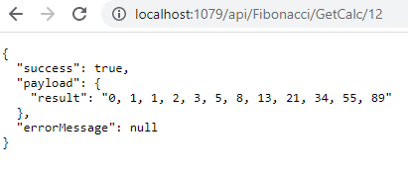

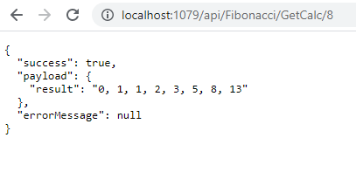

**Failed Response:**

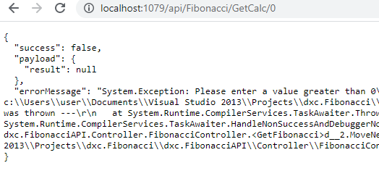

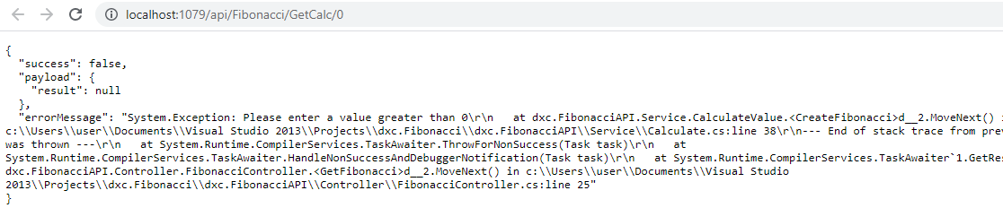

* Also you can run the unit test cases to get the results.
* Please go to the unit test case project (dxc.FibonacciTest) and then go to the class called FibonacciControllerTest.cs. Here you can found the test case.
* Right click on the test case. You can run and debug the test case from here.

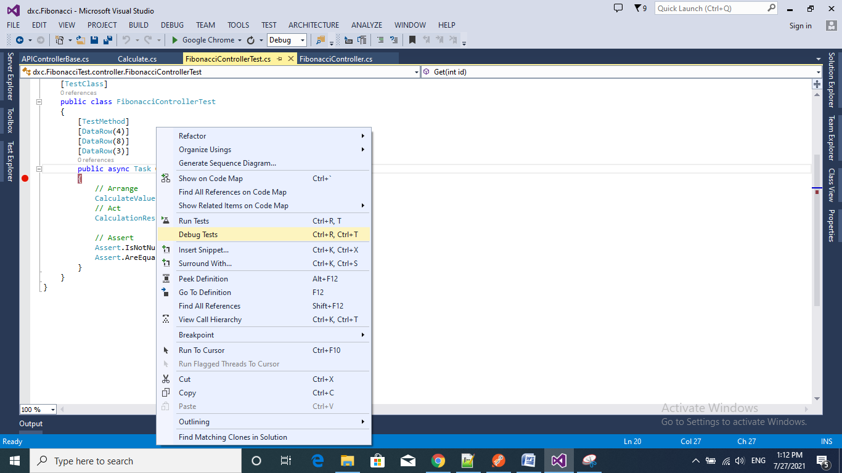

* Also you can test it from Postman. Just use the above URL. And click send button

